Smart Homes
A Novel Approach to Design Programmable Switches using Android and Port Forwarding

Ms. Devika A. Jadhav
Ms. Nikita N. Narsinghani
KIT’s College of Engineering,Kolhapur

Abstract— This paper aspires to showcase a unique prototype of ‘home automation system’ based on Internet of Things (IoT). The proposed approach presents an idea to control and monitor innumerable electrical loads such as lights, fans, air-conditioner, refrigerators and washing machine, through a user friendly Android-based interface. The Android application provides a graphical interface to control the central embedded system over internet. This system further switches the current state of an electric load and sends an acknowledgement of the performed action to the user. This provides the user with exclusive privileges to remotely access the electrical loads and sensors within the network. The simplified design of the proposed system allows easy customization and extension of automation as per user requirements. A highlight of this approach is utilization of port-forwarding facility provided by internet routers. This approach reduces costs related to setting up a network substantially.

Keywords: Home Automation, Intelligent Control, Android, Port Forwarding.

- INTRODUCTION
The sole objective of technology is to reduce human efforts. Automation is one of such alluring technologies that makes human life easy by reducing physical efforts and also aids to power conservation. It started with a simple infrared remote controller and ever since then, it has been evolving with great pace. Technologies like ZigBee[2], SMS[3, 4], Dual-Tone Multi-Frequency (DTMF)[5] and control of automation system through computers using customized websites[6], have all been used and researched over for application of automation.
Today internet has become an inevitable part of human life that has connected the world together. Internet has all the supportive features beneficial to make an efficient automation system. There have been several new methodologies emerging that make use of internet either through cell phone GPRS/3G network[8], a customized website or Java application[6], running a web based server on an Arduino Ethernet[9] and the latest being the most trending, Internet of Things (IoT)[8].
The drastic advancements in the Smartphone technology have widened the scope for use of smart cell phones. It was not long ago that Google introduced us to Android-a whole new generation of advanced smart phones. With easy and open source Java based development tools, networking and connecting to remote hardware and embedded systems over internet has been made possible using Android.
Due to these key factors we choose Android, networking over internet and an easy and simplified central automation system as the main highlights of our paper.

- PREVIOUS WORK
Earlier, the concept of home automation was as simple as turning ON or OFF an electrical appliances using a simple remote controller, as used in [1]. But, this restricts the control of the automation system to a certain area.
SMS based automation system presented in [3, 4], allow the user to access and control the automation system through cell phones. There were several limitations of this technique as it required the user to know the strict pattern of characters for sending AT commands and there was no GUI for the system. This methodology for remote access pioneered the idea of controlling such systems using a cellphone. Another technique used was DTMF[5], but again, the lack of a graphical interface and complex usability along with calling costs to activate and control the system, resulted in limited use of such methodology.
Many new methods using Java applications and customized web-sites[6] emerged but the necessity of a high-end PC as the web server, increased the overall cost of the system. Several systems have been developed that use Android and internet gateway for communication [8-11]. These approaches used have presented intelligent control of automation systems either by using a micro-web server running on an Arduino Ethernet[9], a PC based server[10], use of HTTP and 3G network[12] or features like voice control[11] and local Bluetooth connectivity[9].This invariably gave a more simplified solution than using ZigBee[2], where complex installation and appropriate configuration of a private network of sensors and controlling devices has to be installed.
The effective and simplified methods provided by Android to communicate with embedded systems over Internet were found to be promising. Some innovative ideas like use of Dynamic Domain Name Service(DDNS) to retrieve current public IP address of the automation system[12], along with security for the Android application [10], effective transmission of switching signals and responding to acknowledgements from the system inspire this project.

- SYSTEM ARCHITECTURE

The most important facets of this automation system are the central embedded system, the Android application that controls the system and the communication structure that enables the modules of the system to communicate within certain secured boundaries

  - Central Embedded System
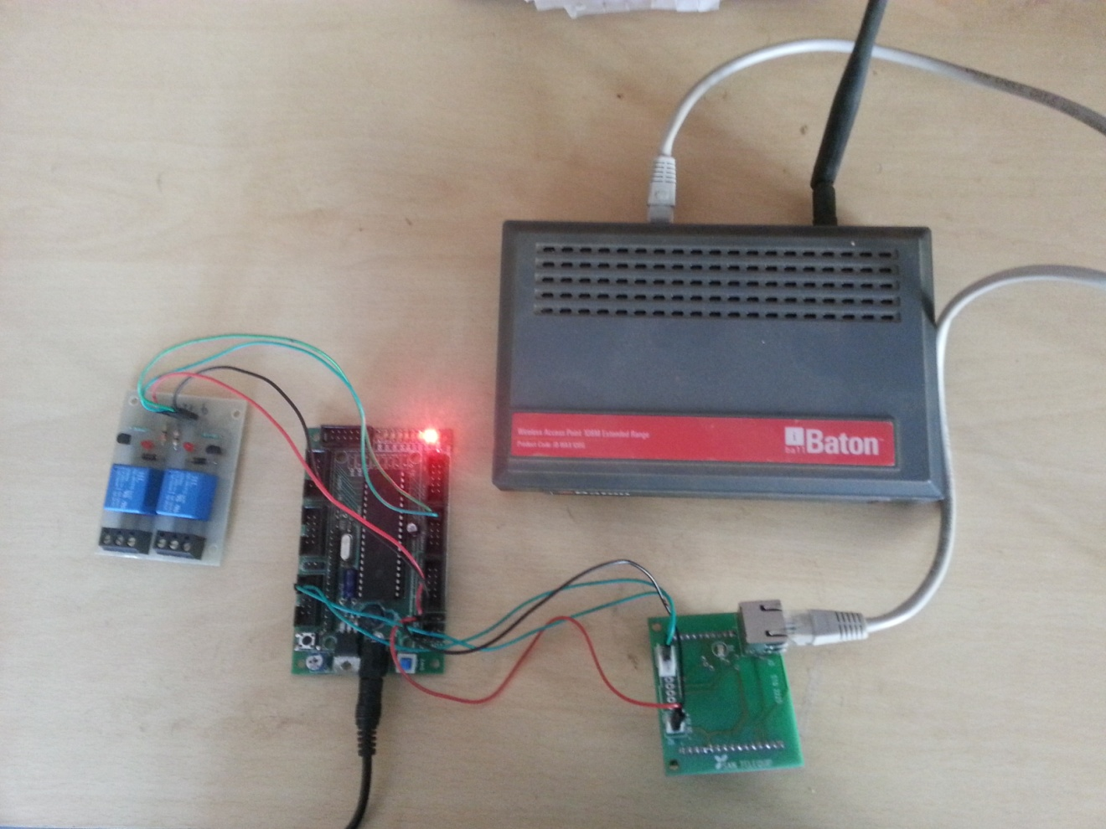
Fig. 1 The central embedded system connected to the router

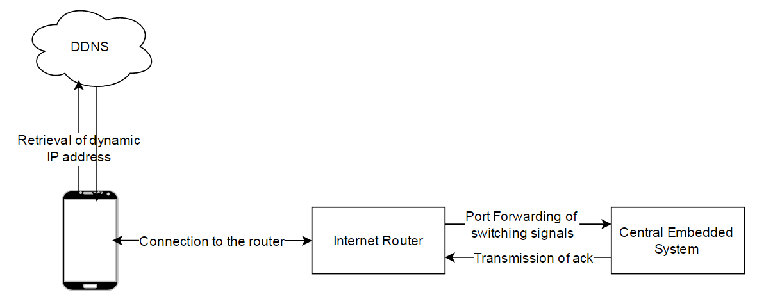
The central embedded system is further divided into 3 modules – the Ethernet to Serial converter, Arduino UNO microcontroller board and the relay circuit. This division is done for easy understanding and demonstration purpose and all these modules can be designed on a single development board. The Ethernet to Serial converter is connected to the microcontroller board through the Rx (Receiving) and Tx (Transmitting) pin of USART communication. The Arduino UNO microcontroller board used, supports rapid prototyping with connections to all its ports and pins through a systematic layout. The relay circuit can be connected to individual pins or ports as per the designed switching logic. The electrical loads like fans, lights, etc. can be connected to the relay circuit to be a part of the automation system. This comprises of the central embedded system. Although this system is designed on Arduino UNO microcontroller, it can be substituted with any other microcontroller board as long as it supports the functions of Ethernet to Serial conversion and simple logic programming.
Fig. 2 Communication structure of the system
Retrieval of dynamic IP address

  - Android Application

The android application is developed considering simple installation and easy to understand operation. When the application is installed and started for the very first time, the application asks the user to set up a user id and password. This adds to the security of the application as any unauthorized access is blocked through its login page. The application is designed in such a way that it checks for connectivity to the router prior to entering the home page. The rooms and sub-sections of the property are outlined on the home page and appropriate selections guides the user to the switching of the electrical loads in that particular room or section. This application is developed using the open source Android Software Development Kit provided by Google.

  - Communication Structure

The communication network is the core aspect of this project as reliable transmission and reception of the switching signals is the prime prerequisite of such an automation system. The IP address of the router may change dynamically, which makes it difficult to address the router with a certain public IP address. Hence, we use DDNS service, where the router is given a hostname and addressed using it. The central embedded system has a local IP address and is connected to the router using RJ45 LAN cable. This system is allocated a certain port range (e.g. 8800-8810). Port Forwarding, the supported function of a router, is used to transfer the signals to the central embedded system through the local IP address and the allocated port.
- SYSTEM IMPLEMENTATION
When the user handles the system, there are series of steps taken for the user instructions to be implemented. The main execution is carried out at the android application, the reception/transmission of signals over the network setup and the hardware implementation.

  - Working of Android application
During the first run of the application, the user is prompted to setup a user id and password. This data is saved in the application data. The application directs the user to the login page for every next time the application is opened. After successful user authentication, the application fetches the current public IP address of the router from DDNS host name. Only after the retrieval of public IP and verifying the connectivity to the embedded system through the router, the application enters the home page. Here the user can select the desired room and the application further directs the user to the specific room page, where the user can control the electrical loads. Also, when the application navigates to the selected room page, the current state of the electrical loads is updated and displayed. This is done by sending a ping and the system replying with the current status of all the devices. When the user switches the state of the appliance, a signal is transmitted to the embedded system and only upon an acknowledgement from the system, the application reflects the change on the User Interface.
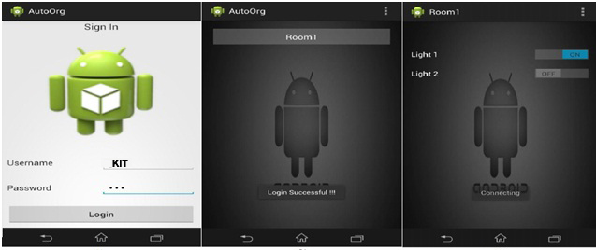
Fig. 3 Screenshots of Android application
  - Networking

The prime focus of this prototype is to inspire remote access to the automation system and to achieve this efficient and reliable networking of modules is necessary. The entire networking structure of this prototype is based on Internet. When the user opens the Android application the initial connectivity to the router is done by retrieving the current IP address of the router through a DDNS server. The application sends a ping to the central system and upon receiving an acknowledgement the connection to the central system is established. All the signals transmitted/received thereafter follows the same link and the application responds only after acknowledgements from the central system. These signals are directed towards the specific declared port of the router to which the central embedded system is connected. Once the signals reach the router, the signals are forwarded to the system after a lookup in the port forwarding table. The protocol used here can be TCP or UDP. This port forwarding table is configured while installation of the system.
After the messages are forwarded to the central system, the signals undergo Ethernet to serial conversion. This serial data has to be communicated to the microcontroller in order to perform the desired logic. This is accomplished using the USART communication protocol. The Ethernet-Serial converter exhibits a Tx and Rx pin for transmission and receiving of data. Likewise, pin 14 and pin 15 of Arduino UNO act as Rx and Tx of the microcontroller. This is how serial data from the Ethernet-Serial converter is communicated to the Arduino UNO microcontroller board.

  - Logic Design at Central Embedded System
The central embedded system consists of an Ethernet to Serial converter, Arduino UNO microcontroller board and the relay circuit. The Ethernet-Serial converter is connected to the router via RJ45 LAN cable. This module converts the Ethernet data into Serial data and transmits it to the Arduino UNO microcontroller.
Upon receiving the signals the Arduino UNO microcontroller checks for the signal, confirms the action to be taken as per the program and sends switching signals to the relay module. The programming methodology used is simple bit manipulation. Also an important feature of the programming methodology used is that for every action an acknowledgement is generated and transmitted over to the user handling the Android application. A simple 1 or 0 bit is transmitted to the relay circuit and the switching operation is performed. For this experiment, two light bulbs were connected to the relay circuit.

- CONCLUSION AND FUTURE SCOPE
Even though this project uses Atmega16 microcontroller development board, this same prototype can be easily migrated to any other development board that supports simple binary logic.Thus, we can add to the advantage of the system that it is not bound to any specific microcontroller requirements until the logic implemented is similar.
The scope of this system can be extended to regulation of the appliances that we can control. This will extended the functionality of the system from switching of the appliances to controlling them. Heavy electrical loads like Air Conditioner, etc. can be added to this system provided a suitable circuit should be designed for it.
The three modules, Ethernet-Serial converter, Arduino UNO microcontroller board and the relay circuit can be integrated on a single board. This will make it a task specific board and other unnecessary functionalities can be minimized. The android application can be updated to keep up-to-date with the new android versions. With this proposed future work, this prototype will provide a promising solution for Home Automation.
With features such as easy integration of sensors, user-friendliness , quick-response architecture a real-time monitoring and remote access, this system is a comparable system to current state-of-the-art applications-based on IoT. The implementation of IoT supports integration of physical world in a computer-based system to provide more accurate, efficient and cost-efficient results. Thus embedding automation in the simplest of forms will make our life easy and will take us a step closer towards smart living.

REFERENCES

[1] N. Hasan, A. A. M. Khan, N. Uddin, and A. F. Mitul, "Design and implementation of touchscreen and remote control based home automation system," in International Conference on Advances in Electrical Engineering (ICAEE), 2013., 2013, pp. 347-352.
[2] A. C. Olteanu, G. D. Oprina, N. Tapus, and S. Zeisberg, "Enabling Mobile Devices for Home Automation Using ZigBee," in 19th International Conference on Control Systems and Computer Science (CSCS), 2013., 2013, pp. 189-195.
[3] H. Elkamchouchi and A. ElShafee, "Design and prototype implementation of SMS based home automation system," in IEEE International Conference on Electronics Design, Systems and Applications (ICEDSA), 2012., 2012, pp. 162-167.
[4] T. Begum, M. S. Hossain, M. B. Uddin, and M. S. H. Chowdhury, "Design and development of activation and monitoring of home automation system via SMS through microcontroller," in 4th International Conference on Computers and Devices for Communication, 2009. CODEC 2009., 2009, pp. 1-3.
[5] W. Tao, L. Yanping, and G. Huanbing, "The smart home system based on TCP/IP and DTMF technology," in 7th World Congress on Intelligent Control and Automation, 2008. WCICA 2008., 2008, pp. 7686-7691.
[6] A. R. Al-Ali and M. Al-Rousan, "Java-based home automation system," IEEE Transactions on Consumer Electronics, vol. 50, pp. 498-504, 2004.
[7] M. Kovatsch, M. Weiss, and D. Guinard, "Embedding internet technology for home automation," in IEEE Conference on Emerging Technologies and Factory Automation (ETFA), 2010., 2010, pp. 1-8.
[8] R. Piyare, "Internet of things: ubiquitous home control and monitoring system using android based smart phone," International Journal of Internet of Things, vol. 2, pp. 5-11, 2013.
[9] S. Kumar and L. Seong Ro, "Android based smart home system with control via Bluetooth and internet connectivity," in The 18th IEEE International Symposium on Consumer Electronics (ISCE 2014), 2014., 2014, pp. 1-2.
[10] A. Gurek, C. Gur, C. Gurakin, M. Akdeniz, S. K. Metin, and I. Korkmaz, "An Android based home automation system," in 10th International Conference on High Capacity Optical Networks and Enabling Technologies (HONET-CNS), 2013., 2013, pp. 121-125.
[11] N. bt Aripin and M. B. Othman, "Voice control of home appliances using Android," in Electrical Power, Electronics, Communications, Controls and Informatics Seminar (EECCIS), 2014, 2014, pp. 142-146.
[12] N. Liu, H. Yan, and C. Guan, "Design and Implementation of a Smart Home Control System," in Third International Conference on Instrumentation, Measurement, Computer, Communication and Control (IMCCC), 2013., 2013, pp. 1535-1538.

